IN Liugong UAT Customer Master Screen defects

In Liugong, the Manage Customer Master screen has a bug in some widgets. Even when invalid data is entered, the page is still being submitted instead of displaying validation errors.
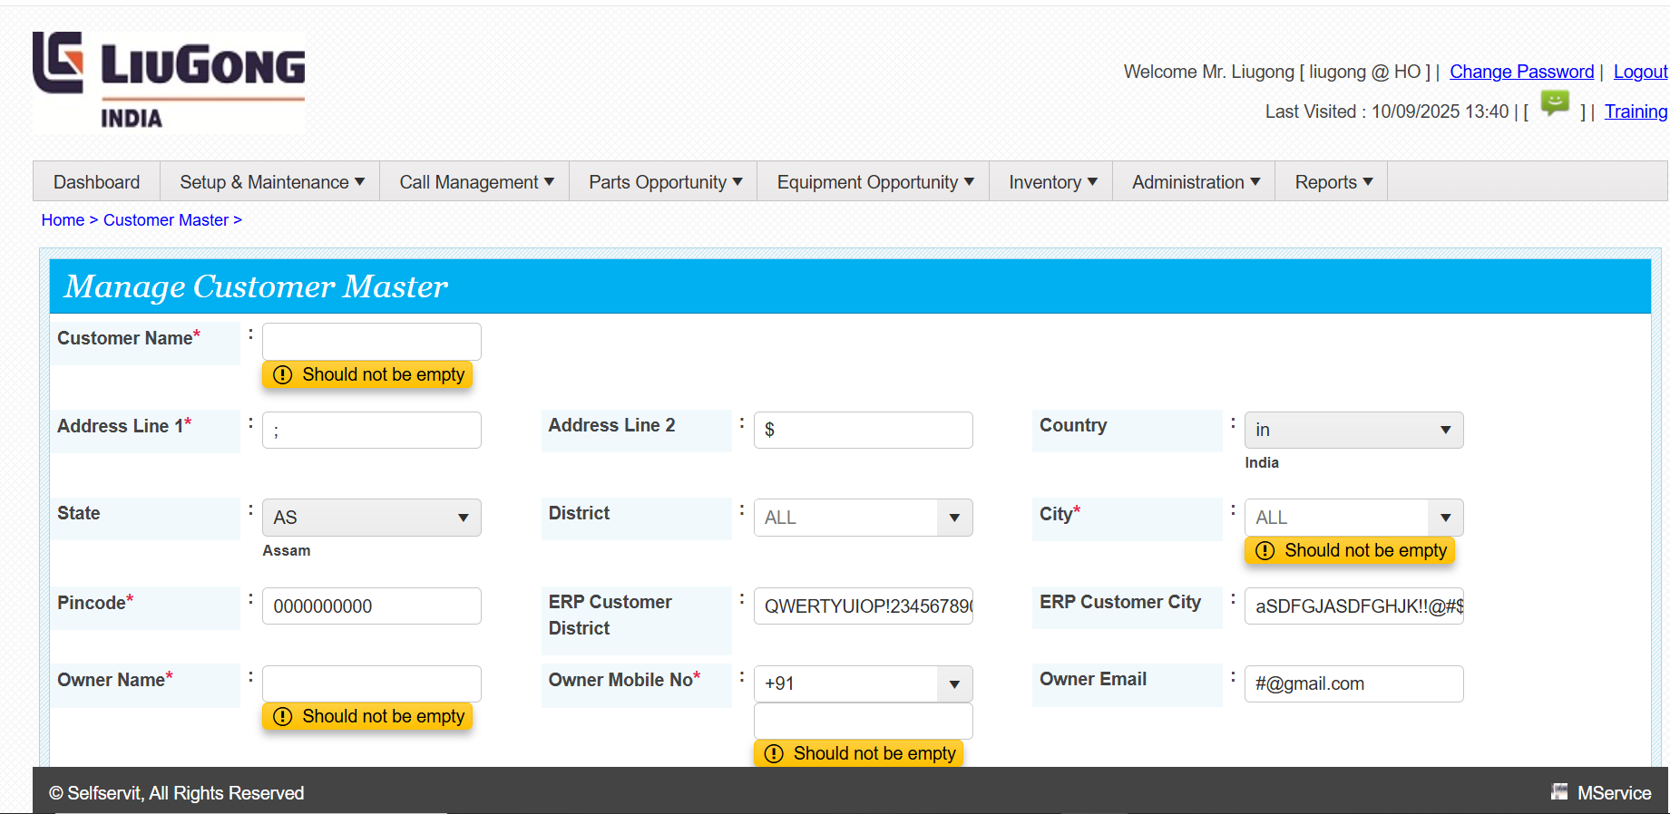
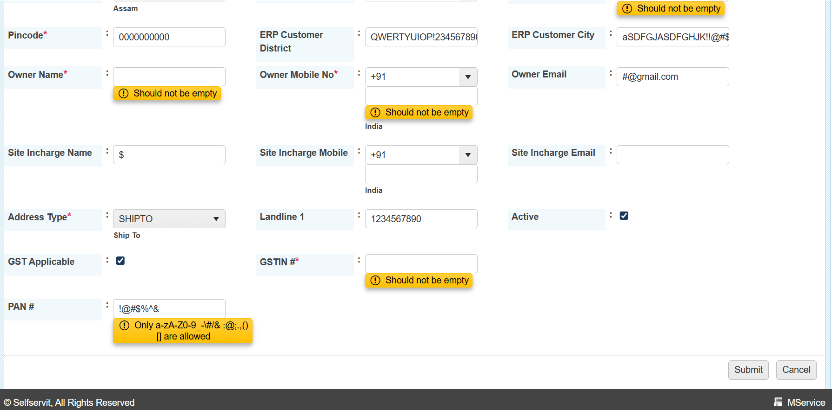

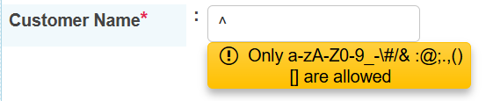

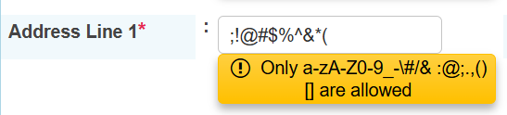

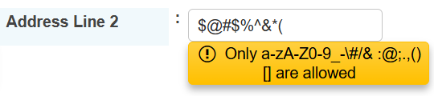

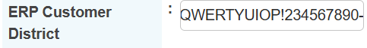

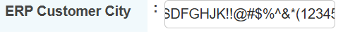

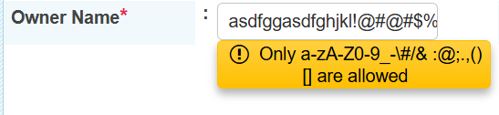

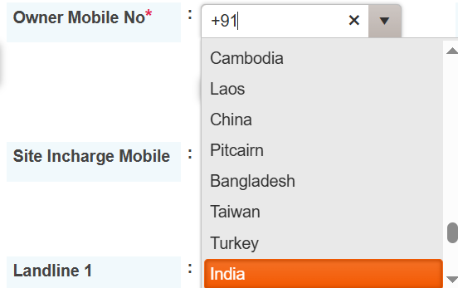
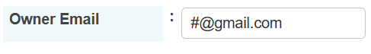

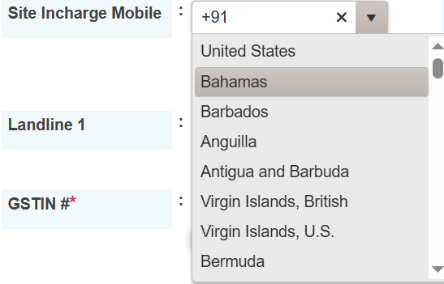
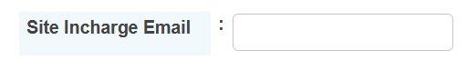
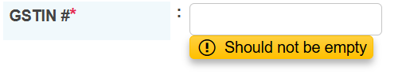

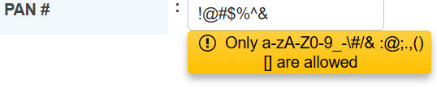

As per the Liugong UAT, on the Manage Customer Master page certain requirements were mentioned. However, when entering input into the widgets, they are not functioning properly.(defect occurs)

Below, I have mentioned both the requirement and the defects observed, where the widgets are incorrectly accepting invalid inputs

Customer Name:
Requirements : Only a-zA-Z0-9_-\#/& :@;.,()[] are allowed
Defect : $ % * ‘ + . This all are also accepted

Address Line 1:
Requirements : Only a-zA-Z0-9_-\#/& :@;.,()[] are allowed Defect : $ % * ‘ + . This all are also accepted.
Address Line 2:
Requirement : Only a-zA-Z0-9_-\#/& :@;.,()[] are allowed
Defect : $ % & * ‘ + . This all are also accepted.
ERP Customer District:
- The field is accepting alphabets, numbers, and special characters, which should not be allowed.
- There is no restriction on the character limit for input in the field.
ERP Customer City:
- The field is accepting alphabets, numbers, and special characters, which should not be allowed.
- There is no restriction on the character limit for input in the field.
Owner Name:
Requirements : Only a-zA-Z0-9_-\#/& :@;.,()[] are allowed
Defect : $ % * ‘ + . This all are also accepted.
Owner Mobile No :
In this screen, the dropdown options are not arranged properly.

Owner Email:
In this field eg: aswin@g it accept and submit it did not show error like invalid Gmail.
Site Incharge Name:
Requirements : Only a-zA-Z0-9_-\#/& :@;.,()[] are allowed
Defect : $ % * ‘ + . This all are also accepted.
Site Incharge Mobile:
In this screen, the dropdown options are not arranged properly.
GSTIN # :
Requirements : Only a-zA-Z0-9_-\#/& :@;.,()[] are allowed
Defect : $ % * ‘ + . This all are also accepted.
PAN # :
Requirements : Only a-zA-Z0-9_-\#/& :@;.,()[] are allowed
Defect : $ % * ‘ + . This all are also accepted.

